PROJECT DOCUMENTATION
Time-Series Forecasting of Monthly Milk Production
Using Recurrent Neural Networks (SimpleRNN, LSTM, and GRU)
Prepared by: Eeda Uday Kiran
Source notebook: Text_Classification_using_RNN_.ipynb
Prepared: August 2026

Table of Contents
Table of Contents 1
0. A Note on the Notebook Title 1
1. Project Overview 1
1.1 Objectives 1
1.2 Dataset 1
2. Technology Stack 1
3. Code Walkthrough 1
3.1 Imports and Reproducibility Setup 1
3.2 Step 1 — Exploratory Data Analysis (EDA) 1
3.3 Step 2 — Data Preparation for Deep Learning 1
3.3.1 Chronological Train / Validation / Test Split 1
3.3.2 Scaling 1
3.3.3 Sliding-Window Sequence Creation 1
3.4 Step 3 — Model Building (RNN, LSTM, GRU) 1
3.5 Step 4 — Model Evaluation 1
3.6 Step 5 — Forecasting the Next 12 Months 1
3.7 Step 6 — Business Insights 1
4. Model Comparison Logic 1
5. Outputs Produced 1
6. How to Run the Project 1
7. Limitations and Suggested Improvements 1
8. Conclusion 1

0. A Note on the Notebook Title
The uploaded notebook is named “Text_Classification_using_RNN_.ipynb”, but its actual content is not a text-classification task. It is a univariate time-series forecasting project that predicts future monthly milk production using three types of recurrent neural networks: SimpleRNN, LSTM, and GRU. This documentation describes the project based on what the code actually does, not the filename. If a text-classification version of this project was also intended, that code was not present in the uploaded file.

1. Project Overview
This project builds and compares three recurrent neural network architectures — SimpleRNN, LSTM, and GRU — to forecast monthly milk production using historical time-series data. The pipeline covers exploratory data analysis, data preprocessing, model training, performance evaluation, 12-month-ahead forecasting with confidence intervals, and a concluding business-insights summary aimed at supporting operational decisions in a dairy production setting.

1.1 Objectives
- Analyze historical monthly milk production data to identify trend and seasonal patterns.
- Prepare the data appropriately for sequence-based deep learning models (scaling, windowing, chronological splitting).
- Build and train three recurrent architectures (SimpleRNN, LSTM, GRU) on the same data and settings for a fair comparison.
- Evaluate and compare model performance using RMSE, MAE, and MAPE on a held-out test set.
- Select the best-performing model and use it to forecast the next 12 months, with an approximate 95% confidence interval.
- Translate the results into actionable business recommendations.

1.2 Dataset
File: monthly_milk_production (1).csv
Field | Description
Date | Monthly timestamp (parsed as YYYY-MM and set as the DataFrame index).
Production | Milk production volume (lbs) recorded for that month.

2. Technology Stack
Category | Libraries / Tools Used
Data handling | NumPy, Pandas
Visualization | Matplotlib
Deep learning | TensorFlow / Keras (Sequential API: SimpleRNN, LSTM, GRU, Dense, Dropout, Input, EarlyStopping)
Preprocessing / metrics | scikit-learn (MinMaxScaler, mean_squared_error, mean_absolute_error)
Statistical decomposition | statsmodels (seasonal_decompose)

3. Code Walkthrough
The notebook is organized into six sequential stages. Each stage is explained below in the order it appears in the code, along with the reasoning behind each step.

3.1 Imports and Reproducibility Setup
The notebook begins by importing all required libraries and fixing a random seed.
import numpy as np, pandas as pd, matplotlib.pyplot as plt
import tensorflow as tf
from tensorflow.keras.models import Sequential
from tensorflow.keras.layers import Input, SimpleRNN, LSTM, GRU, Dense, Dropout
from tensorflow.keras.callbacks import EarlyStopping
from sklearn.preprocessing import MinMaxScaler
from sklearn.metrics import mean_squared_error, mean_absolute_error
SEED = 42
np.random.seed(SEED); tf.random.set_seed(SEED)
Setting SEED = 42 for both NumPy and TensorFlow makes weight initialization and data shuffling reproducible across runs, so results can be compared reliably between the RNN, LSTM, and GRU experiments.

3.2 Step 1 — Exploratory Data Analysis (EDA)
The CSV is loaded, the Date column is converted to a proper datetime index, and the series is sorted chronologically:
df = pd.read_csv("monthly_milk_production (1).csv")
df["Date"] = pd.to_datetime(df["Date"], format="%Y-%m")
df.set_index("Date", inplace=True)
df.sort_index(inplace=True)
Basic diagnostics follow: shape, head, describe, and a missing-value check, giving a quick sense of data size, range, and completeness.
Outlier detection uses the Interquartile Range (IQR) method — values below Q1 − 1.5×IQR or above Q3 + 1.5×IQR are flagged — to check whether extreme production values need special handling before modeling.
Three visual diagnostics are then produced and saved as PNG files:
- A line plot of production over time (01_trend_plot.png) to inspect the overall trend.
- A boxplot of production grouped by calendar month (02_seasonality_boxplot.png) to check for recurring monthly seasonality.
- A seasonal_decompose plot (03_decomposition.png) that splits the series into trend, seasonal, and residual components using an additive model with a 12-month period, confirming the presence of yearly seasonality.
The temporary Month column used only for the boxplot is dropped afterward so it does not leak into the modeling stage.
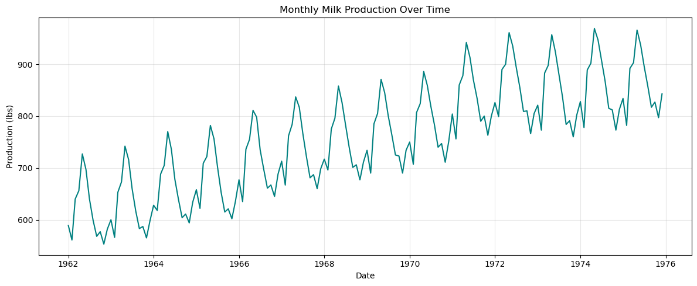
Figure 1. Monthly milk production over time — raw trend (01_trend_plot.png).
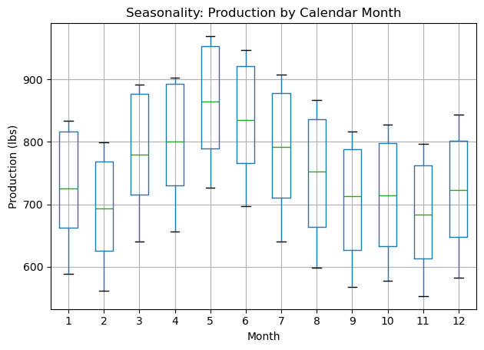
Figure 2. Production distribution by calendar month, showing recurring seasonality (02_seasonality_boxplot.png).
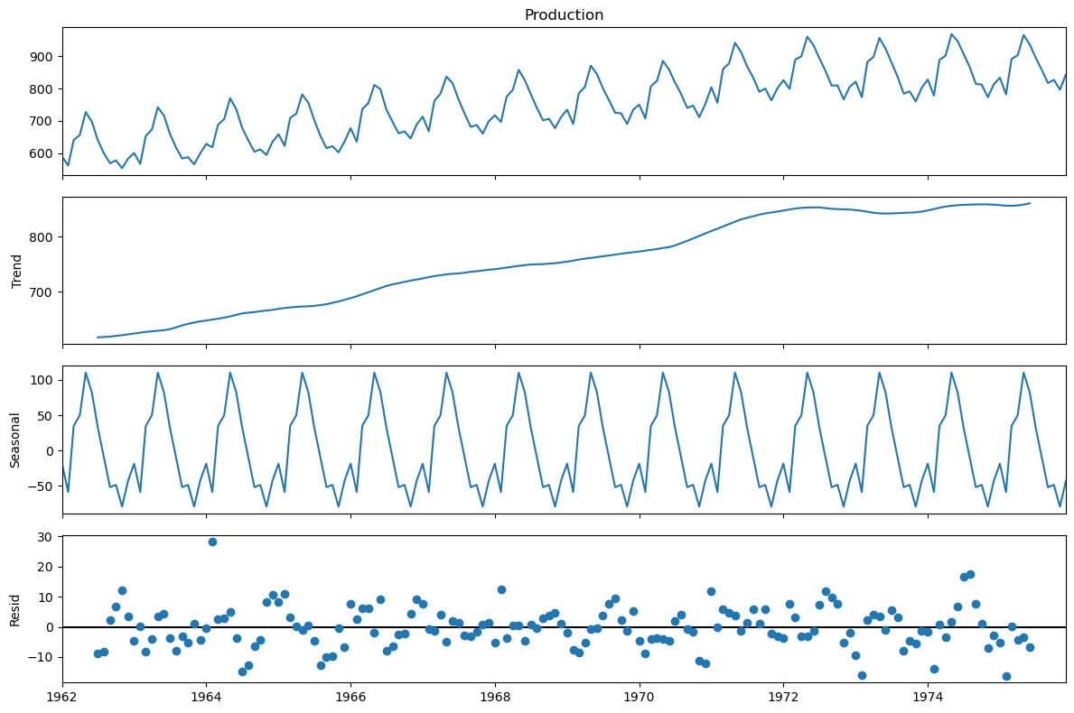
Figure 3. Additive seasonal decomposition into trend, seasonal, and residual components (03_decomposition.png).

3.3 Step 2 — Data Preparation for Deep Learning
This stage transforms the raw series into supervised-learning sequences suitable for an RNN.

3.3.1 Chronological Train / Validation / Test Split
train_size = int(n * 0.70)
val_size = int(n * 0.15)
train_raw = values[:train_size]
val_raw = values[train_size : train_size + val_size]
test_raw = values[train_size + val_size:]
The data is split 70% / 15% / 15% into train, validation, and test sets without shuffling, since shuffling a time series would let the model “see the future” during training — a common and serious mistake in time-series modeling that this notebook correctly avoids.

3.3.2 Scaling
A MinMaxScaler is fit only on the training data and then applied to validation and test data. Fitting the scaler on the full dataset would leak information about the future range of values into training, so restricting the fit to train_raw is the correct practice.

3.3.3 Sliding-Window Sequence Creation
def create_sequences(data, window_size):
X, y = [], []
for i in range(len(data) - window_size):
X.append(data[i : i + window_size, 0])
y.append(data[i + window_size, 0])
return np.array(X), np.array(y)
WINDOW_SIZE = 12 # past 12 months predict the next month
Each input sequence (X) consists of 12 consecutive months of production, and the target (y) is the value of the 13th month. To avoid discarding the first 12 points of the validation and test sets, the last WINDOW_SIZE points of the preceding split are prepended before windowing (val_input, test_input). Finally, the sequences are reshaped to the 3D shape (samples, timesteps, features) required by Keras recurrent layers.

3.4 Step 3 — Model Building (RNN, LSTM, GRU)
def build_model(layer_type, units=64, window_size=WINDOW_SIZE, dropout=0.2):
layer_map = {"RNN": SimpleRNN, "LSTM": LSTM, "GRU": GRU}
RecurrentLayer = layer_map[layer_type]
model = Sequential([
Input(shape=(window_size, 1)),
RecurrentLayer(units, activation="tanh"),
Dropout(dropout),
Dense(1)
])
model.compile(optimizer="adam", loss="mse", metrics=["mae"])
return model
A single reusable factory function builds a one-layer recurrent network with 64 units and tanh activation, followed by a Dropout(0.2) layer for regularization and a Dense(1) output layer for the single-value forecast. The same architecture, optimizer (Adam), and loss (MSE) are used for all three layer types, which keeps the comparison between RNN, LSTM, and GRU fair.
Training configuration:
Parameter | Value
Epochs | 100 (maximum)
Batch size | 16
Early stopping | monitor=val_loss, patience=10, restore_best_weights=True
EarlyStopping halts training if validation loss does not improve for 10 consecutive epochs and restores the weights from the best epoch, which helps prevent overfitting. Each of the three models (RNN, LSTM, GRU) is trained in a loop and stored in the models and histories dictionaries for later comparison.

3.5 Step 4 — Model Evaluation
Validation loss curves for all three models are plotted together (04_val_loss_comparison.png) to visually compare convergence behavior.
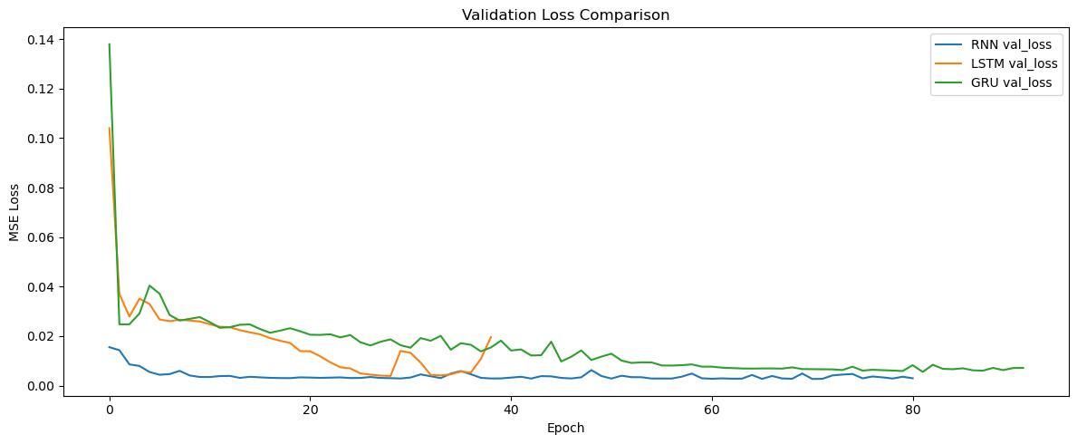
Figure 4. Validation loss (MSE) across training epochs for SimpleRNN, LSTM, and GRU (04_val_loss_comparison.png).
A custom MAPE (Mean Absolute Percentage Error) function is defined, since scikit-learn does not provide one directly:
def mape(y_true, y_pred):
return np.mean(np.abs((y_true - y_pred) / y_true)) * 100
For each trained model, predictions on the test set are generated, inverse-transformed back to the original production scale using the fitted scaler, and compared against actual values to compute three error metrics:
Metric | What it measures
RMSE | Root Mean Squared Error — penalizes larger errors more heavily; same units as production (lbs).
MAE | Mean Absolute Error — average magnitude of error, same units as production (lbs).
MAPE | Mean Absolute Percentage Error — error as a percentage, useful for comparing across scales.
A combined chart (05_predictions_vs_actual.png) overlays the actual test-set values with each model’s predictions. Results are collected into a DataFrame, and the model with the lowest RMSE is automatically selected as best_model_name for the forecasting stage.
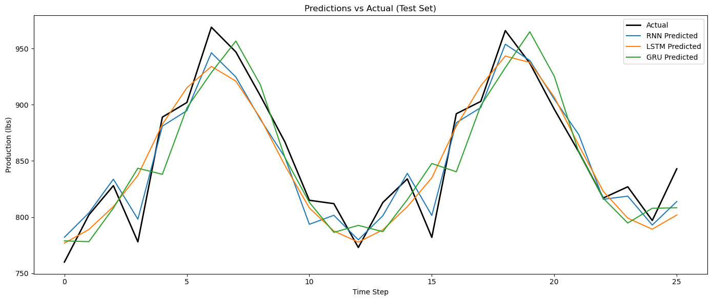
Figure 5. Test-set predictions vs. actual production for all three models (05_predictions_vs_actual.png).

3.6 Step 5 — Forecasting the Next 12 Months
def forecast_future(model, last_window, n_steps=12):
forecast_scaled = []
current_window = last_window.copy()
for _ in range(n_steps):
input_seq = current_window.reshape(1, current_window.shape[0], 1)
next_pred = model.predict(input_seq, verbose=0)[0, 0]
forecast_scaled.append(next_pred)
current_window = np.append(current_window[1:], [[next_pred]], axis=0)
return scaler.inverse_transform(np.array(forecast_scaled).reshape(-1, 1))
This function performs recursive (iterative) multi-step forecasting: it predicts one month ahead, appends that prediction to the input window while dropping the oldest month, and repeats for 12 steps — effectively using the model’s own predictions as future inputs. The best model (selected by lowest test RMSE) is used, starting from the last available 12-month window.
A 95% confidence interval is approximated using the standard deviation of the residuals (actual minus predicted) on the test set, applying the standard ± 1.96×σ rule. The forecast, its upper/lower bounds, and the full historical series are plotted together (06_future_forecast.png).
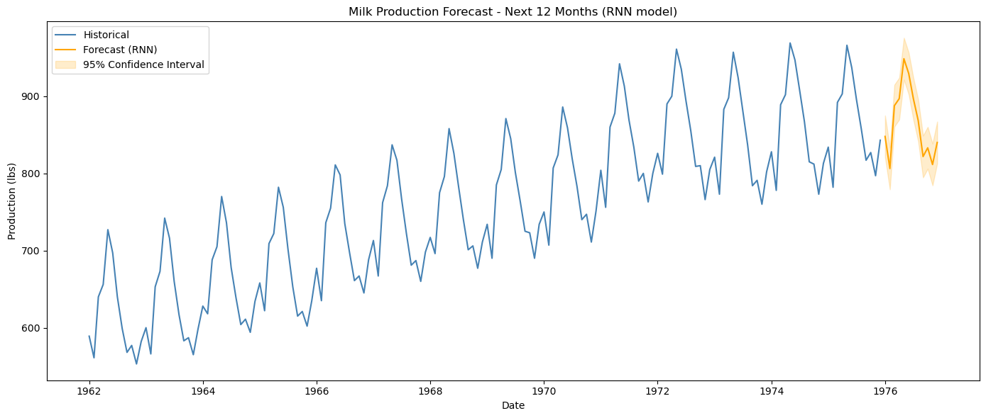
Figure 6. Historical production plus the 12-month forecast with 95% confidence band (06_future_forecast.png).

3.7 Step 6 — Business Insights
The final cell prints a formatted summary covering: the trend and seasonal pattern observed in the data (peaks around May–June, dips around November–December), the best-performing model along with its RMSE/MAE/MAPE, and practical recommendations — planning storage and cold-chain capacity, scheduling workforce and logistics, using the confidence interval in supply negotiations, and flagging months where actual production deviates strongly from the forecast as potential anomalies worth investigating.

4. Model Comparison Logic
All three architectures share identical preprocessing, window size, hyperparameters, and training budget, so the comparison isolates the effect of the recurrent cell type itself:
Model | Key Characteristic
SimpleRNN | Basic recurrent cell; simplest and fastest, but more prone to vanishing-gradient issues on longer sequences.
LSTM | Uses input/forget/output gates and a cell state; typically better at capturing longer-term dependencies.
GRU | A simplified gated architecture (update/reset gates); often trains faster than LSTM with comparable accuracy.
The model with the lowest test-set RMSE is programmatically chosen (idxmin()) as the one used for final forecasting, removing subjective bias from model selection.

5. Outputs Produced
File | Content
01_trend_plot.png | Raw production trend over time
02_seasonality_boxplot.png | Production distribution by calendar month
03_decomposition.png | Trend / seasonal / residual decomposition
04_val_loss_comparison.png | Validation loss curves for RNN vs. LSTM vs. GRU
05_predictions_vs_actual.png | Test-set predictions vs. actual values, all models
06_future_forecast.png | 12-month forecast with 95% confidence band

6. How to Run the Project
- Place “monthly_milk_production (1).csv” in the same working directory as the notebook.
- Install dependencies: numpy, pandas, matplotlib, tensorflow, scikit-learn, statsmodels.
- Run all cells sequentially from top to bottom — later cells depend on variables created earlier (df, scaler, models, results, best_model_name).
- Review the generated PNG files and the printed model-comparison table and forecast values.

7. Limitations and Suggested Improvements
- Single-feature (univariate) model: only past production values are used; external factors (herd size, weather, feed cost) are not included.
- Recursive forecasting compounds errors over the 12-step horizon, since later predictions depend on earlier predicted values rather than true observations.
- The confidence interval is an approximation based on test-set residual standard deviation, not a full predictive distribution.
- Only one configuration per architecture is tested; hyperparameter tuning (units, window size, layers, dropout) could further improve accuracy.
- With ~one seed and one train/val/test split, results may vary somewhat with different splits or seeds; cross-validation on time series (e.g., rolling-origin evaluation) would give a more robust estimate.

8. Conclusion
The notebook implements a complete, methodologically sound time-series forecasting pipeline: it correctly avoids data leakage (chronological splitting, scaler fit on training data only), fairly compares three recurrent architectures under identical conditions, quantifies model performance with standard regression metrics, and translates the best model's forecast into concrete, actionable business recommendations for dairy production planning.

